COURSE FRAMEWORK TEMPLATE GUIDE

GENERAL INFORMATION
COURSE TITLE |  |  | COURSE NUMBER
Discrete Math |  |  | 201-SF5-RE
PROGRAM CODE AND TITLE |  |  | PROGRAM COMPONENT
200.C1 Computer Science and Math |  |  | Program-specific (Pre-U)
PREREQUISITES | SEMESTER | PONDERATION |  | TOTAL CONTACT HRS | TOTAL HOMEWORK HRS
Secondary V mathematics. Technical or science option, CEGEP course 201-015-RE  Co-requisite: 201-SN4-RE Linear Algebra | 1 | 3-2-3 |  | 75 | 45

COURSE’S ROLE IN THE PROGRAM
This course introduces students to the tools and techniques of discrete mathematics. Topics include: set theory, logic, introduction to number theory, principles of counting, recurrence relations, a survey of graph theory, and application of matrices to graphs.

Briefly describe the course and situate it within the context of the program by explaining its relationship with other courses.

COURSE-LEVEL LEARNING OUTCOME
Analyze problem by applying discrete mathematics.
Learning outcomes are observable, measurable actions that demonstrate students’ learning (i.e., the attainment of the competencies and transversal learning). Learning outcomes should be descriptive statements expressed with action verbs. They must reflect the level of learning expected of students taking the course—a level which is determined by the course competency(ies). Consulting a taxonomy (such as Bloom’s) is useful for developing appropriately leveled learning outcome statements.
The course-level learning outcome is a concise expression of the learning students will develop in the course. It aligns with the statement(s) of the course competency(ies). It is a descriptive statement expressed with (an) action verb(s) and is typically a sentence or two in length.

KEY LEARNING OUTCOMES
1: Make appropriate use of methods of discrete mathematics in the context of the various science problems.

2: Be able to accurately apply proof techniques.
3: Be able to appropriately use the language of the set theory and functions.
4: Apply methods of counting techniques and recursions to modeling the problem.
5: Correctly apply number theory to computing context.
6: Analyze problems using graph theory.

Identify approximately 3 to 6 key learning outcomes that demonstrate student learning in this course. They should lead to the course-level learning outcome. (Note: each key learning outcome should be addressed by an assessment.)

LEARNING INTEGRATION ASSESSMENT (LIA)
The LIA for this course consists of a cumulative final exam worth 40% of the term mark. If it is to the benefit of the student, the LIA will be reweighted to 80% of the course grade. The topics covered on the exam are chosen in accordance with departmental policies which ensure that (all of) the competencies of the course are evaluated. If the final exam is held online, then only the grading scheme in which the final exam is worth 40 % will be used.

EVALUATION CRITERIA FOR THE LEARNING INTEGRATION ASSESSMENT
- Appropriate use of concepts.
- Application of proof techniques.
- Accurate use of set operations.
- Proper recognition of injective, surjective and bijective functions.
- Use of appropriate counting techniques.
- Accuracy of solving linear recurrences.
- Accurate use of concepts of number theory in a computing context.
- Accuracy in use of matrix language in graph context.
- Accurate modelling of a situation using a graph.

List the key criteria by which students will be assessed for this activity. Take into consideration the key learning outcomes for the course. This section is not a marking rubric.
Weight of Grade (%)
40 or 80

Indicate in the box, the percentage of the
final grade that the LIA will be worth.

COMPETENCIES AND TRANSVERSAL LEARNING
CODE | COMPETENCY STATEMENT | PROGRESSION | HOURS | OTHER COURSES CARRYING THE COMPETENCY
0M0D | Analyze problems by applying discrete mathematics. | Comprehensive | 75 | none
CODE | COMPETENCY STATEMENT | PROGRESSION | HOURS | OTHER COURSES CARRYING THE COMPETENCY
CODE | COMPETENCY STATEMENT | PROGRESSION | HOURS | OTHER COURSES CARRYING THE COMPETENCY
CODE | COMPETENCY STATEMENT | PROGRESSION | HOURS | OTHER COURSES CARRYING THE COMPETENCY
 |  | Choose an item.

TRANSVERSAL LEARNING
The course will reinforce a systematic approach to problem-solving. Students will be asked to reason logically. They will become familiar with the context in which scientific concepts are discovered and developed.

Students will be able to provide a justification of their steps in problem-solving procedures using methods of number and of graph theory. They will use of algebraic operations in conformity with rules. Students will know how to translate word problems into mathematical language with the help of the concepts of discrete mathematics.

Transversal learning is not explicitly mentioned in the course competency(ies) but is needed across different disciplines in the program (e.g. professional attitudes and essential skills such as communication, research, and ICT skills). It may be mapped to multiple courses. (See, for example the Aims of College Education and the Common Competencies of College Education.)

STUDENT PROFICIENCY IN THE LANGUAGE OF INSTRUCTION (SPLI)
Student proficiency in the language of instruction is the ability to write, read, speak, and listen in order to communicate effectively at the college level. SPLI may also require discipline-specific vocabulary, documentation, and communication skills; assessment of language skills must account for a minimum of 10% of any take-home written assignment or oral presentation in which English is the language of expression.
There are no mandatory written assignments in this course, but mathematical calculations.

PEDAGOGICAL STRATEGIES AND ASSESSMENTS
Describe how students will develop their learning and how that learning will be assessed in the course.
. Quizzes, Tests, Assignments are used in this course.
- Key formative, summative, or integrative assessments (Note: each key learning outcome should be addressed by an assessment.)
- Key learning activities
- Pedagogical strategies that support learning in this course
You may also make recommendations to support your colleagues in teaching the course. For example, you may choose to include concise descriptions of the following:
- Suggestions for real-world contexts for activities or assessments that help support learning: Symmetric and asymmetric cryptography
- Suggestions for sequencing of main steps or stages of learning: The student acquires mathematical concepts and connects these concepts to real life through applications
- Suggestions for course materials agreed on by the department: as approved by the department.

APPENDIX 1 – EXCERPT OF THE MINISTERIAL DEVIS
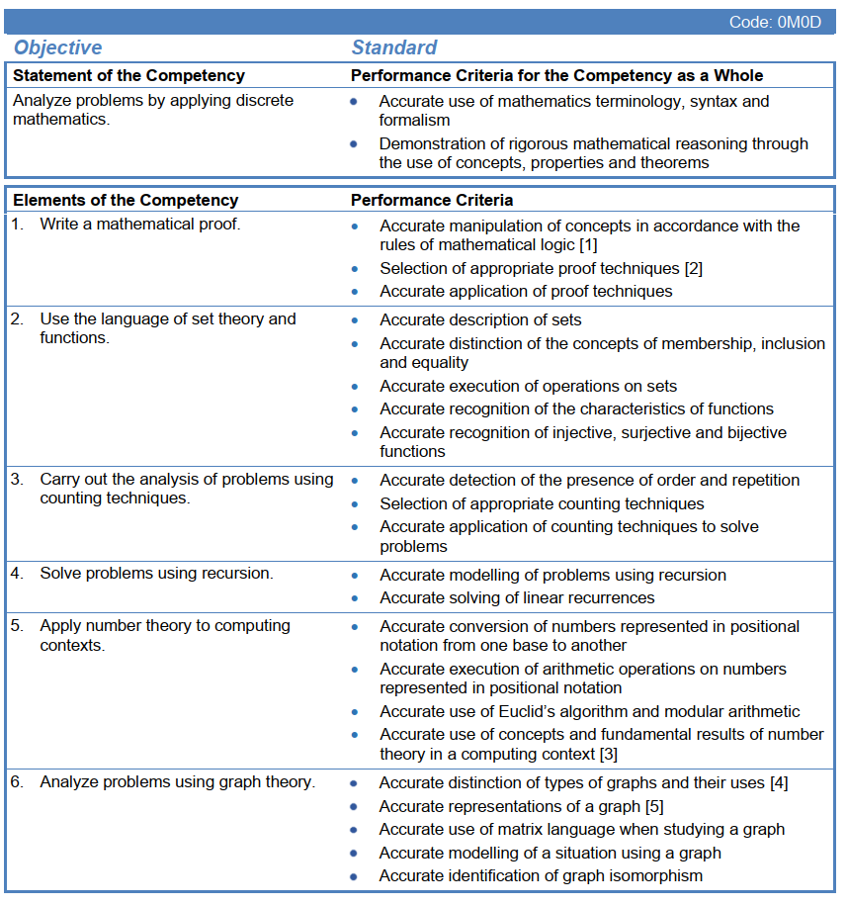

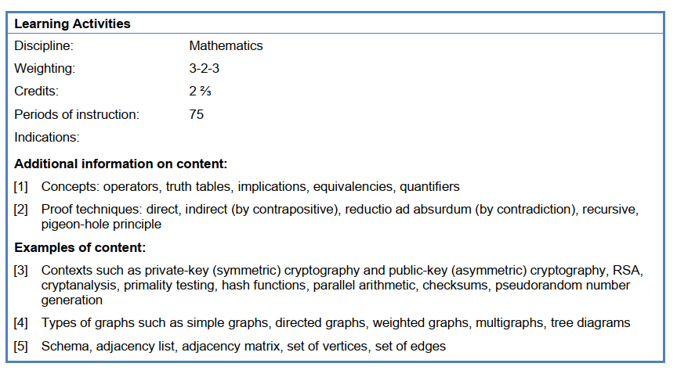

APPENDIX 2 – COURSE DESCRIPTION

The course description is an optional part of the course framework. It should be written after all other sections have been developed. The course description will be used in several instances such as Clara, the master schedule, the Prospectus, the website course description, and course outlines.

This course provides an understanding of the fundamental notions of number theory and graphs. It introduces the concept of discrete mathematics in application to various scientific problems.

